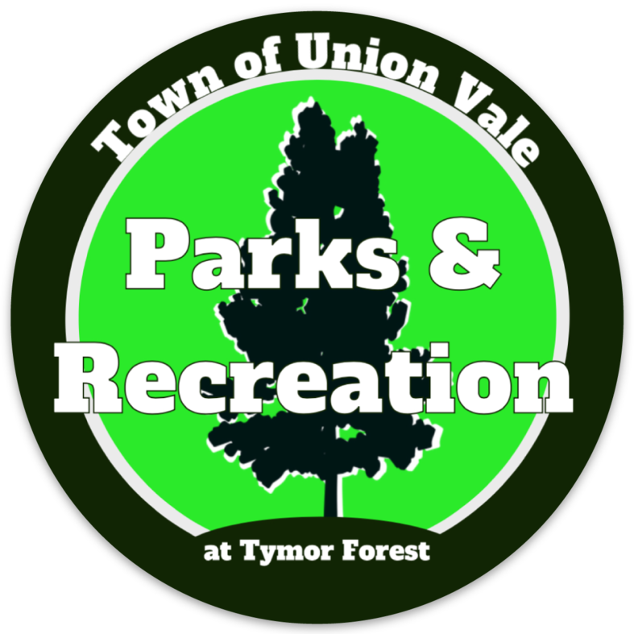
ALL medical records must be in our Recreation Office PRIOR to your child’s start date. If ALL 3 FORMS are not received, your child will not be able to attend camp/program. No refunds. No exceptions. We cannot guarantee follow up reminders as it is a parent responsibility to make sure all paperwork is received.
RECREATION OFFICE USE ONLY
OTHER MED FORMS RECEIVED ! 1) Yearly Physical 2) Immunization Record
MANDATORY PHYSICIAN’S ORDERS
This page to be filled out by a physician and returned to:
249 Duncan Rd, LaGrangeville, NY 12540
(845) 724-5691 (PHONE) (845)724-5692 (FAX) tymorpark@unionvaleny.us

 |  |  | / /
Child’s LAST Name |  | Child’s FIRST Name | Date of Birth | Date of Last Physical
Address |  | Town | State | Zip

Program: Δ Traditional Camp Δ Kids Camp Δ CIT Program Δ TGTT Full Day Δ TGTT After-School

Camp Session: Δ 1 Δ 2 Δ 3 Δ 4

Standard Over the Counter/PRN Medications (The following medications are available and will be administered at the discretion of the Health Director or designee, if approval is indicated by the camper’s Healthcare Provider.)

Drug Name | Route | Dosage | Indications | Physician’s Order |  | Comments
Antibiotic Ointment | Topical | Per label instructions | Superficial cuts/ abrasions | Yes | No
Hydrocortisone Cream | Topical | Per label instructions | Allergic reactions (contact dermatitis, insect bites) | Yes | No
Calamine Lotion  (or generic) | Topical | Per label instructions | Allergic reactions (hives, insect bite) | Yes | No
Saline Solution/Eye Wash | Topical | Per label instructions | Dust/sand in the eyes | Yes | No
Sting Relief | Topical | Per label instructions | Insect bite | Yes | No
Alcohol Wipes | Topical | Per label instructions | Superficial cuts/abrasions | Yes | No

Prescription Medications This includes Epi-Pens, Ritalin, etc. CAMPER MUST BE ABLE TO SELF-ADMINISTER. Please complete with the patient’s current regimen for both scheduled and PRN medications.

Drug Name | Route | Dosage & Schedule | Indications | Camper Health Care Provider Order | Comments
This form must be completed and signed by the child’s physician.
This form must be filled out and signed for all campers. Campers taking any prescription medications while at camp must be able to self- administer the medication under the supervision of the Camp Health Director/Designee.
On-Site Camp Health Directors are only permitted to dispense medications that are listed on this form by the child’s doctor.
Physician’s Name: Phone#: Address: License#: Signature: Date:

